Q1

#include <unistd.h>

#include <stdio.h>

#include <sys/stat.h>

#include <stdlib.h>

#include <dirent.h>

#include <string.h>

int main()

{

DIR *mydir;

char *c;

int i;

struct dirent *myfile;

struct stat fileStat;

mydir = opendir(".");

stat(".", &fileStat);

while ((myfile = readdir(mydir)) != NULL)

{

stat(myfile->d_name, &fileStat);

if (strcmp(myfile->d_name, ".") != 0 && strcmp(myfile->d_name, "..") != 0)

{

printf("%s\n", myfile->d_name);

printf("File Permission:\n");

printf((S_ISDIR(fileStat.st_mode)) ? "d" : "-");

printf((fileStat.st_mode & S_IRUSR) ? "r" : "-");

printf((fileStat.st_mode & S_IWUSR) ? "w" : "-");

printf((fileStat.st_mode & S_IXUSR) ? "x" : "-");

printf((fileStat.st_mode & S_IRGRP) ? "r" : "-");

printf((fileStat.st_mode & S_IWGRP) ? "w" : "-");

printf((fileStat.st_mode & S_IXGRP) ? "x" : "-");

printf((fileStat.st_mode & S_IROTH) ? "r" : "-");

printf((fileStat.st_mode & S_IWOTH) ? "w" : "-");

printf((fileStat.st_mode & S_IXOTH) ? "x" : "-");

printf("\n");

}

}

closedir(mydir);

return 0;

}

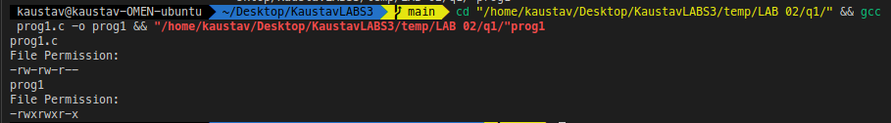

Q2

#include <unistd.h>

#include <sys/stat.h>

#include <stdlib.h>

#include <stdio.h>

#include <string.h>

#include <dirent.h>

void printdir(char *dir, int depth)

{

DIR *dp;

struct dirent *entry;

struct stat statbuf;

if ((dp = opendir(dir)) == NULL)

{

fprintf(stderr, "cannot open directory: %s\n", dir);

return;

}

chdir(dir);

while ((entry = readdir(dp)) != NULL)

{

lstat(entry->d_name, &statbuf);

if (S_ISDIR(statbuf.st_mode))

{

if (strcmp(".", entry->d_name) == 0 || strcmp("..", entry->d_name) == 0)

continue;

printf("%*s%s/\n", depth, " ", entry->d_name);

printdir(entry->d_name, depth + 4);

}

else

printf("%*s%s/\n", depth, " ", entry->d_name);

}

chdir("..");

closedir(dp);

}

int main(int argc, char const *argv[])

{

/* code */

printdir(".", 0);

exit(0);

}



Q3

#include <unistd.h>

#include <sys/stat.h>

#include <stdlib.h>

#include <stdio.h>

#include <string.h>

#include <dirent.h>

void printdir(char *dir, int depth)

{

DIR *dp;

struct dirent *entry;

struct stat statbuf;

if ((dp = opendir(dir)) == NULL)

{

fprintf(stderr, "cannot open directory: %s\n", dir);

return;

}

chdir(dir);

while ((entry = readdir(dp)) != NULL)

{

lstat(entry->d_name, &statbuf);

if (S_ISDIR(statbuf.st_mode))

{

if (strcmp(".", entry->d_name) == 0 || strcmp("..", entry->d_name) == 0)

continue;

printf("%*s%s/\n", depth, " ", entry->d_name);

printdir(entry->d_name, depth + 4);

}

else

printf("%*s%s/\n", depth, " ", entry->d_name);

}

chdir("..");

closedir(dp);

}

int main(int argc, char const *argv[])

{

/* code */

printdir("/usr/bin", 0);

exit(0);

}

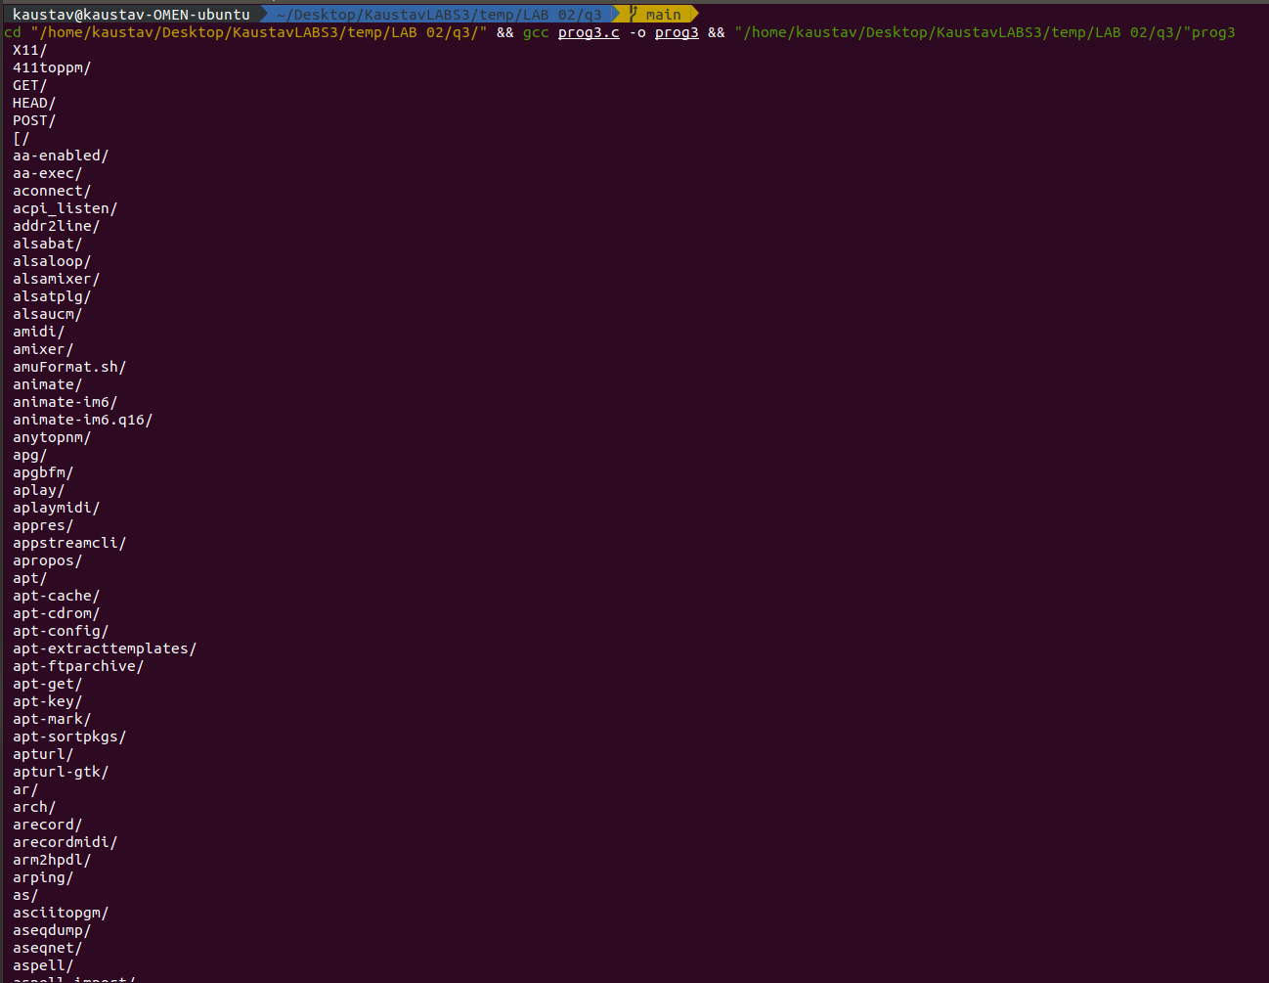

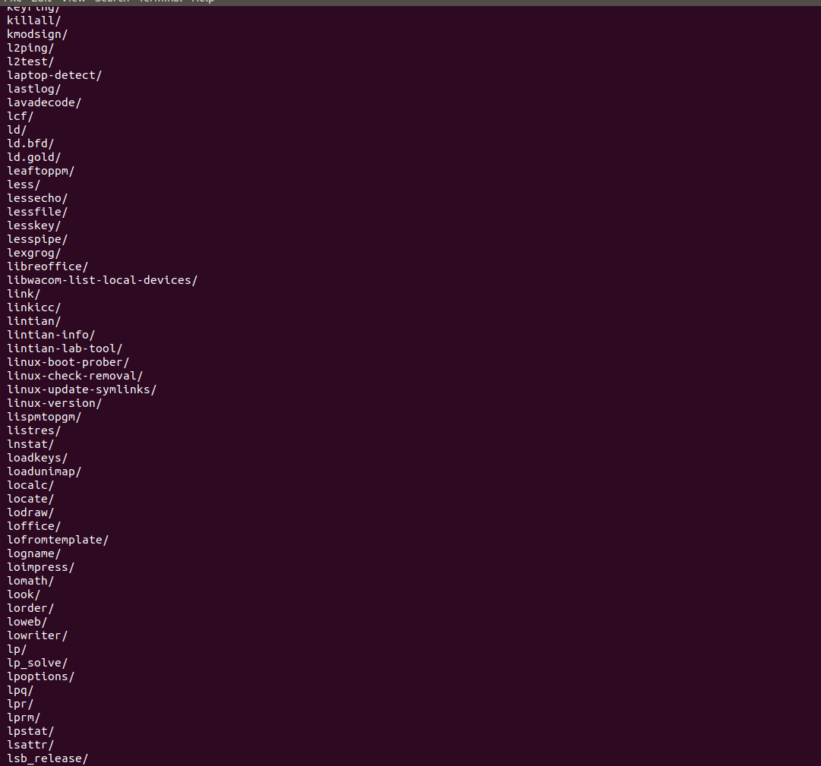

Q4

#include <unistd.h>

#include <sys/stat.h>

#include <stdlib.h>

#include <stdio.h>

#include <string.h>

#include <dirent.h>

void printdir(char *dir, int depth)

{

DIR *dp;

struct dirent *entry;

struct stat statbuf;

if ((dp = opendir(dir)) == NULL)

{

fprintf(stderr, "cannot open directory: %s\n", dir);

return;

}

chdir(dir);

while ((entry = readdir(dp)) != NULL)

{

lstat(entry->d_name, &statbuf);

if (S_ISDIR(statbuf.st_mode))

{

if (strcmp(".", entry->d_name) == 0 || strcmp("..", entry->d_name) == 0)

continue;

printf("%*s%s/\n", depth, " ", entry->d_name);

printdir(entry->d_name, depth + 4);

}

else

printf("%*s%s/\n", depth, " ", entry->d_name);

}

chdir("..");

closedir(dp);

}

int main(int argc, char const *argv[])

{

/* code */

printdir("/dev", 0);

exit(0);

}

